**Project name** : E-WS

**Frontend :** Frontend development is programming which focuses on the visual elements of a website that a user will interact with.

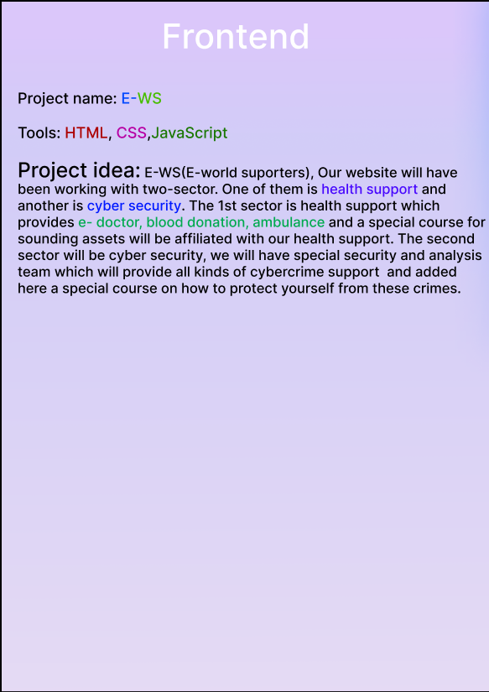

This is our frontend. Basically this website will be working in two sectors. One of them is health support and another one is cyber security. The health support provides E-doctor, blood donation, ambulance. In case of cyber security, we will have special security and analysis team which will provide all kinds of cybercrime and support.

**Backend :** Back end development focuses on the side of a website users can't see.

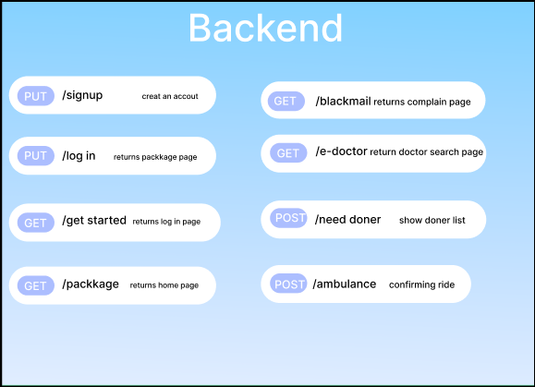

The GET method is used to retrieve data from the server.

The POST method sends data to the server and creates a new resource.

The PUT method is most often used to update an existing resource.

**‘PUT sign up’** will lead to the sign up page and require informations about user.

**‘PUT log in’** will lead to the login page.

**‘GET blackmail’** will collect user’s complain.

**‘GET e-doctor’** will lead to doctor list page . User can search there about doctor.

**‘POST donor’** will show a list of donors according to user’s need.

**Database :** A database is an organized collection of structured information, or data, typically stored electronically in a computer system.

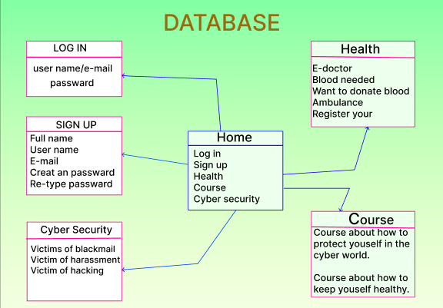

In database, all the five boxes are related to home box and vice versa. Here in sign up box user will give their information to create an account. If user has already an account then he will have to login that. Then he will come to the home page again and go to any other pages.